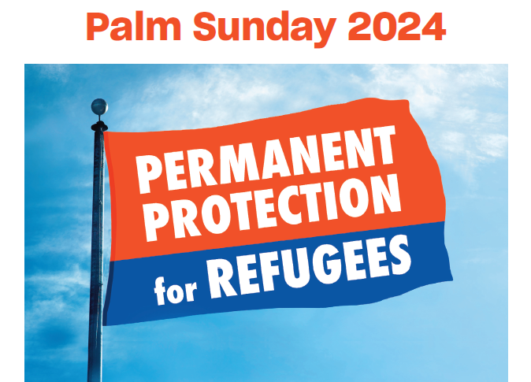

This Information Kit for Churches includes:
- Context – why Palm Sunday is an important day to call for justice for refugees
- How your church can help to promote Palm Sunday activities
- Display a Justice for Refugees BANNER – see order form below
- Ideas for sermons and prayers for Palm Sunday
- A link to a Resource for use in Christian schools
- Further background information on current refugee issues
Palm Sunday is a time to reflect on the plight of refugees, forced to flee their homes and their homeland because of war and/or political oppression.

Congregations might like to include a focus on refugees in their services, and the actions they can take to call for Justice for Refugees. A selection of prayers for refugees that may be adapted for use in congregations – see link below.

Poster for Palm Sunday Walk for Justice

Leaflet - Palm Sunday Walk for Justice

WHY FAITH COMMUNITIES CALL FOR JUSTICE FOR REFUGEES ON PALM SUNDAY
The call to show loving kindness and care for our neighbours, to welcome the stranger, and to uphold the worth and dignity of each person, is central to our Christian beliefs and practices. At the same time, advocacy may be needed as part of our response to the lived experience of the vulnerable and marginalised. It may also require a challenge to unjust systems that perpetuate inequity and disadvantage. Christians may contribute to respectful public dialogue with policy makers so that constructive change can happen.
Palm Sunday each year is an occasion to bear witness to the priority of compassion and to call for justice for refugees and asylum seekers. It is also a time to celebrate the contribution that so many refugees have made to Australian society in a wide range of endeavours. It is a time to stand together.
Across Australia, in capitals cities and in local communities, there will be actions calling for Justice for Refugees, and Permanent Protection for ALL Refugees who are here in Australia. For information about where local actions will be held, and other more general information about Palm Sunday, including a leaflet and poster – go to https://aran.net.au/actions/palm-sunday-2024/
HOW YOUR CHURCH HELP TO PROMOTE PALM SUNDAY ACTIVITIES
- Make mention of the need for Justice for Refugees in your services on Palm Sunday
- Make sure the poster and leaflet is displayed and available in your church
- Consider ordering a Justice for Refugees banner for display outside your church (Possibly on a permanent basis) – see below details for ordering a banner from the Refugee Advocacy Network
- Encourage your members to an action in their local area if there is one – see https://aran.net.au/actions/palm-sunday-2024/#listingevents
- See suggestions for contacting politicians to raise concerns with them at Lobby politicians
- Donate to a refugee support organisation in your area

IDEAS FOR SERMONS AND SERVICES ON PALM SUNDAY
Prayers
- Prayer by the Anglican Diocese of Melbourne: https://aran.net.au/wp-content/uploads/2022/03/Palm-Sunday-Prayer.pdf
- Commongrace Prayers: https://www.commongrace.org.au/asylum_pray
Link to video clip - Rev. Dr. Katherine Rainger, Holy Covenant Anglican Church (Canberra) calling on people to attend the Palm Sunday rallies for Justice for Refugees in whichever town or city they live. https://www.youtube.com/watch?v=S4lyyqjwnOw
Notes for Sermons
The Gospel stories of the entry of Jesus to Jerusalem on a donkey, on what we now call Palm Sunday, is well known. The crowds shouted, ‘Hosanna to the Son of David! Blessed is he who comes in the name of the Lord! Hosanna in the highest heaven!’ (cf Psalm 118:25-26). The crowds recognised the event as fulfilment of ancient prophesy (Zechariah 9.9). “Rejoice greatly, Daughter Zion! Shout, Daughter Jerusalem! See, your king comes to you, righteous and victorious, lowly and riding on a donkey, on a colt, the foal of a donkey”. This king would be the non-violent king, a king of peace: "He will cut off the chariot from Ephraim and the war horse from Jerusalem; and the battle bow shall be cut off, and he shall command peace to the nations" (9.10).
Thus it was, that Jesus chose to ride "the most unthreatening, most un-military mount imaginable: a female nursing donkey with her little colt trotting along beside her" (John Dominic Crossan). In their compelling book, The Last Week: What the Gospels Really Teach About Jesus' Last Days in Jerusalem, Crossan and Borg argue that two processions entered Jerusalem on that first Palm Sunday. Every year, the Roman governor of occupied Judea would ride up to Jerusalem from his coastal residence in the west, specifically to be present in the city for Passover - the annual Jewish festival that swelled Jerusalem's population from its usual 50,000 to at least 200,000. It was a politically volatile time, with the risk of riots as the Jewish people recalled Passover and the ancient victory over Egypt, and fanned the flames of hope for their liberation from Roman occupation. Pilate brought with him soldiers and cavalry to reinforce the imperial garrison in Jerusalem. It made an impressive military procession, designed to intimidate the Jewish people and remind them Rome was in charge, and watching.
The entry of Jesus into Jerusalem was a carefully staged counter-procession to the pomp and power of the Roman empire. Each proclaimed two very different and contrasting visions of how this world can and should be: the kingdom of God versus the kingdoms and the powers of this world. The former is about justice and the end of violence. The latter is about domination and exploitation.
The Palm Sunday Walk for Refugees is a contemporary procession through city streets. Some people will hold signs and banners, some will sing songs, some will call out for compassion and justice. Some onlookers may pause to look for a moment as the procession passes by, and then go about their day. Some will wonder what a group of Christians and concerned citizens can do to change Government policies and practices and put an end to the profiteering of private companies managing offshore facilities that detain vulnerable, traumatised people. Yet those who join the Palm Sunday ‘procession’ remain committed to seeking compassionate and just ways to respond to refugees and asylum seekers.
As we reflect on the plight of refugees, forced to flee their homes and, for many, their homeland, we can see the terrible consequence of war and conflict, and military might. Let us again turn our attention to the way of Jesus, Prince of Peace, and to justice and the end of violence. Let us follow the example of Jesus in offering compassionate care to the most vulnerable in our global village.
BACKGROUND INFORMATION on REFUGEE ISSUES

JUSTICE FOR REFUGEES means:
- Permanent visas and family reunion for all refugees
- Fair and timely assessment of all claims for refugee status
- Health care, work rights, income support, and access to education for all seeking asylum
- Freedom – Release ALL refugees from detention
- Resettlement in Australia for refugees still remaining in Papua New Guinea (PNG)
- Resettlement of UNHCR registered refugees trapped in Indonesia
- An end to offshore processing and detention
- An increase in the humanitarian intake of refugees
While the Labor Government has brought some positive change, and the High Court has put an end to indefinite and arbitrary immigration detention, there are still thousands of refugees and people seeking asylum waiting for a safe and secure future.
ALL Refugees need permanent visas and access to family reunion: In February 2023 the government announced that 19,000 people on temporary TPVs and SHEV visas would be granted permanent visas. However, under the flawed so-called ‘Fast Track System’, around 10,000 people have waited years to have their claims for refugee status determined, and many have been unfairly denied. The process is neither fast nor fair. These people need a fair and thorough review process that acknowledges the changing conditions in the countries they fled. All People seeking recognition as refugees need fair and timely assessment processes:
People who are seeking recognition as refugees need work rights and support in the community: People on bridging visas have no access to income support if they can’t work enough to support themselves and their families. Being on short term visas they often find it difficult to find permanent work. Many do not have work rights or Medicare. They are often struggling in poverty and living in substandard and insecure housing. Adults who want to undertake further training are not eligible to build their work skills.
People who do not have permanent visas are unable to undertake tertiary study unless they pay international student fees. Young children cannot access early childhood education and people with disabilities are being denied NDIS funding.
All people who are seeking asylum need supports and opportunities to live in dignity, and not be at risk of destitution, while they wait for their refugee claims to be assessed.

No refugee or person seeking asylum should be deprived of their liberty: The Albanese Government has released a number of people from long term detention under very punitive conditions. Many of these people have not committed serious crimes, and some have never been charged been accused of committing of any crime. Anyone who has served a prison sentence in Australia should not be further deprived of their liberty but rather, they should be offered rehabilitation and allowed to live in the community.

Australia has abandoned 50 people seeking asylum in PNG and they are now desperate: Having been held in PNG for over 10 years and detained in terrible conditions for much of that time, these people have been abandoned. They need immediate pathways to safe resettlement here in Australia. Australia has spent billions of dollars detaining them in PNG and has a moral and legal duty of care for their welfare.

Offshore processing must end: Around 60 people are now being held on Nauru. They are facing offshore detention and years of uncertainty, paid for by Australians. We cannot allow this to continue. Around 1200 refugees who were held in detention in PNG and Nauru, before being brought here for medical treatment are now living on bridging visas indefinitely in Australia because our government refuses to grant them permanent visas. Most of these people are now working in Australia, paying taxes, and need to be offered secure futures.

Australia needs to provide resettlement for refugees stranded in Indonesia: Around 14,000 refugees and people seeking asylum from Afghanistan, Myanmar and Sri Lanka have been stuck in Indonesia since 2014 when the Australian Government refused to offer resettlement, even those registered with UNHCR. These people cannot be resettled in Indonesia and cannot return to their home countries. Australia must give equal opportunity for resettlement in Australia. Many of these people already have family members here.

The Australian government needs to significantly increase the quota for resettling refugees: The Albanese government has committed to increase the number of refugees to be resettled, and it is encouraging to see that in 2023-24 the quota will be raised to 20,000. Thousands of refugees are desperately waiting for resettlement, and we hope the government will continue to increase the humanitarian intake.

Display a Justice for Refugees BANNER

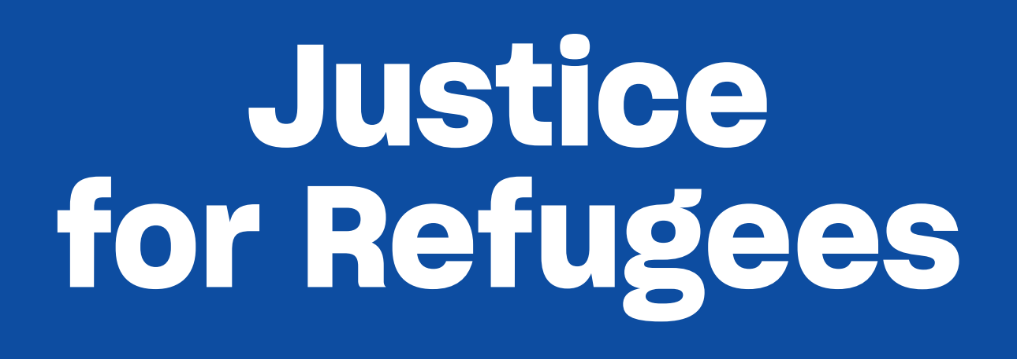

The banner will be 2m wide and 70cm deep – with ropes and eyelets for easy hanging or carrying.

Refugee Advocacy Network has placed a bulk order for vinyl Justice for Refugees banners for use by local groups, local churches, schools etc.

To order a banner send the following information to info@refugeeadvocacynetwork.org.au

Please use the Subject line: Order for banner

Name of your group/church/organisation

Name of contact person

Email for contact person

Mobile for contact person

Number of banners required

Delivery Address

Payment by direct deposit to Refugee Advocacy Network (RAN) Bendigo Bank: BSB: 633 000 Account No: 140311184 Reference= Name of your group
Option 1 – Prepayment: I have made a payment of $50 to the RAN account Yes/No
Option 2– Payment on delivery: I will make a payment of $50 to the RAN account once the banner is received Yes/No
Please indicate clearly which payment option is relevant Note: pre-payment is much preferred!

Send this order form with all requested details to Marie at info@refugeeadvocacynetwork.org.au to secure your order.

